ASSIGNMENT 5
1) #include <iostream>
using namespace std;

class Node {
public:
int data;
Node* next;

Node(int val) {
data = val;
next = nullptr;
}
};

class SinglyLinkedList {
private:
Node* head;

public:
SinglyLinkedList() {
head = nullptr;
}

// Insert at the beginning
void insertAtBeginning(int value) {
Node* newNode = new Node(value);
newNode->next = head;
head = newNode;
}

// Insert at the end
void insertAtEnd(int value) {
Node* newNode = new Node(value);
if (!head) {
head = newNode;
return;
}
Node* temp = head;
while (temp->next) {
temp = temp->next;
}
temp->next = newNode;
}

// Insert before or after a specific node
void insertAfterNode(int key, int value) {
Node* temp = head;
while (temp) {
if (temp->data == key) {
Node* newNode = new Node(value);
newNode->next = temp->next;
temp->next = newNode;
return;
}
temp = temp->next;
}
cout << "Node with value " << key << " not found." << endl;
}

void insertBeforeNode(int key, int value) {
if (!head) return;
if (head->data == key) {
insertAtBeginning(value);
return;
}

Node* temp = head;
while (temp->next && temp->next->data != key) {
temp = temp->next;
}

if (temp->next) {
Node* newNode = new Node(value);
newNode->next = temp->next;
temp->next = newNode;
} else {
cout << "Node with value " << key << " not found." << endl;
}
}

// Delete from the beginning
void deleteFromBeginning() {
if (!head) {
cout << "List is empty!" << endl;
return;
}
Node* temp = head;
head = head->next;
delete temp;
}

// Delete from the end
void deleteFromEnd() {
if (!head) {
cout << "List is empty!" << endl;
return;
}
if (!head->next) {
delete head;
head = nullptr;
return;
}
Node* temp = head;
while (temp->next && temp->next->next) {
temp = temp->next;
}
delete temp->next;
temp->next = nullptr;
}

// Delete a specific node
void deleteNode(int value) {
if (!head) {
cout << "List is empty!" << endl;
return;
}
if (head->data == value) {
Node* temp = head;
head = head->next;
delete temp;
return;
}
Node* temp = head;
while (temp->next && temp->next->data != value) {
temp = temp->next;
}
if (temp->next) {
Node* nodeToDelete = temp->next;
temp->next = temp->next->next;
delete nodeToDelete;
} else {
cout << "Node with value " << value << " not found." << endl;
}
}

// Search for a node and display its position
void searchNode(int value) {
Node* temp = head;
int position = 1;
while (temp) {
if (temp->data == value) {
cout << "Node found at position " << position << endl;
return;
}
temp = temp->next;
position++;
}
cout << "Node with value " << value << " not found." << endl;
}

// Display all nodes
void display() {
if (!head) {
cout << "List is empty!" << endl;
return;
}
Node* temp = head;
while (temp) {
cout << temp->data << " ";
temp = temp->next;
}
cout << endl;
}
};

int main() {
SinglyLinkedList list;
int choice, value, key;

while (true) {
cout << "\nMenu: \n";
cout << "1. Insert at beginning\n";
cout << "2. Insert at end\n";
cout << "3. Insert before/after a node\n";
cout << "4. Delete from beginning\n";
cout << "5. Delete from end\n";
cout << "6. Delete a specific node\n";
cout << "7. Search for a node\n";
cout << "8. Display all nodes\n";
cout << "9. Exit\n";
cout << "Enter your choice: ";
cin >> choice;

switch (choice) {
case 1:
cout << "Enter value to insert at beginning: ";
cin >> value;
list.insertAtBeginning(value);
break;
case 2:
cout << "Enter value to insert at end: ";
cin >> value;
list.insertAtEnd(value);
break;
case 3:
cout << "Enter key (before/after which to insert): ";
cin >> key;
cout << "Enter value to insert: ";
cin >> value;
cout << "Insert before or after? (1 for before, 2 for after): ";
int pos;
cin >> pos;
if (pos == 1) {
list.insertBeforeNode(key, value);
} else {
list.insertAfterNode(key, value);
}
break;
case 4:
list.deleteFromBeginning();
break;
case 5:
list.deleteFromEnd();
break;
case 6:
cout << "Enter value to delete: ";
cin >> value;
list.deleteNode(value);
break;
case 7:
cout << "Enter value to search: ";
cin >> value;
list.searchNode(value);
break;
case 8:
list.display();
break;
case 9:
cout << "Exiting...\n";
return 0;
default:
cout << "Invalid choice! Try again.\n";
}
}
return 0;
}

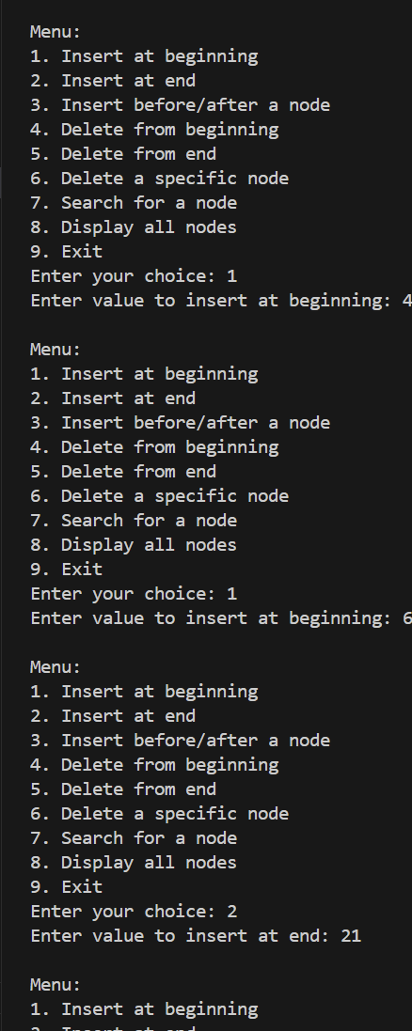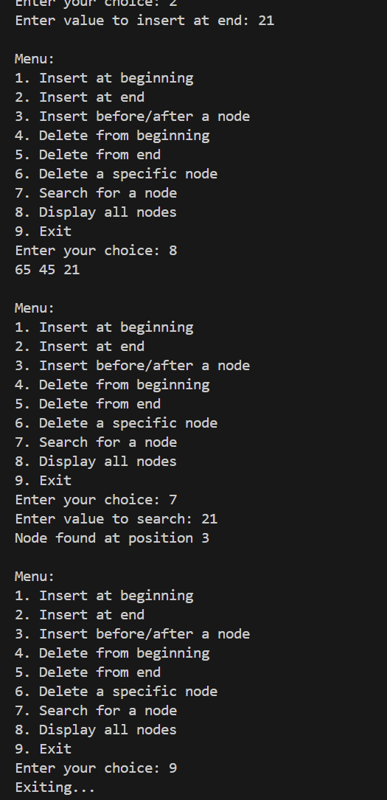
2)
#include <iostream>
using namespace std;

class Node {
public:
int data;
Node* next;

Node(int val) {
data = val;
next = nullptr;
}
};

class SinglyLinkedList {
private:
Node* head;

public:
SinglyLinkedList() {
head = nullptr;
}

void insertAtEnd(int value) {
Node* newNode = new Node(value);
if (!head) {
head = newNode;
return;
}
Node* temp = head;
while (temp->next) {
temp = temp->next;
}
temp->next = newNode;
}

int countOccurrences(int value) {
int count = 0;
Node* temp = head;
while (temp) {
if (temp->data == value) {
count++;
}
temp = temp->next;
}
return count;
}

void deleteOccurrences(int value) {
while (head != nullptr && head->data == value) {
Node* temp = head;
head = head->next;
delete temp;
}

Node* temp = head;
while (temp != nullptr && temp->next != nullptr) {
if (temp->next->data == value) {
Node* nodeToDelete = temp->next;
temp->next = temp->next->next;
delete nodeToDelete;
} else {
temp = temp->next;
}
}
}

void display() {
if (!head) {
cout << "List is empty!" << endl;
return;
}
Node* temp = head;
while (temp) {
cout << temp->data << " ";
temp = temp->next;
}
cout << endl;
}
};

int main() {
SinglyLinkedList list;
int value, key;

list.insertAtEnd(1);
list.insertAtEnd(2);
list.insertAtEnd(1);
list.insertAtEnd(2);
list.insertAtEnd(1);
list.insertAtEnd(3);
list.insertAtEnd(1);

cout << "Original Linked List: ";
list.display();

cout << "Enter the key to count its occurrences: ";
cin >> key;
int count = list.countOccurrences(key);
cout << "Occurrences of " << key << ": " << count << endl;

list.deleteOccurrences(key);
cout << "Linked List after deleting all occurrences of " << key << ": ";
list.display();

return 0;
}

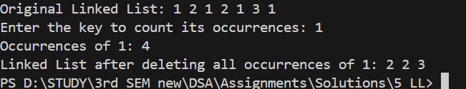

3)
#include <iostream>
using namespace std;

class Node {
public:
int data;
Node* next;

Node(int val) {
data = val;
next = nullptr;
}
};

class SinglyLinkedList {
private:
Node* head;

public:
SinglyLinkedList() {
head = nullptr;
}

void insertAtEnd(int value) {
Node* newNode = new Node(value);
if (!head) {
head = newNode;
return;
}
Node* temp = head;
while (temp->next) {
temp = temp->next;
}
temp->next = newNode;
}

int findMiddle() {
if (!head) return -1;

Node* slow = head;
Node* fast = head;

while (fast && fast->next) {
slow = slow->next;
fast = fast->next->next;
}

return slow->data;
}

void display() {
if (!head) {
cout << "List is empty!" << endl;
return;
}
Node* temp = head;
while (temp) {
cout << temp->data << " ";
temp = temp->next;
}
cout << endl;
}
};

int main() {
SinglyLinkedList list;
int value;

list.insertAtEnd(1);
list.insertAtEnd(2);
list.insertAtEnd(3);
list.insertAtEnd(4);
list.insertAtEnd(5);

cout << "Original Linked List: ";
list.display();

int middle = list.findMiddle();
cout << "Middle of the Linked List: " << middle << endl;

return 0;
}

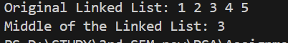

4)
#include <iostream>
using namespace std;

class Node {
public:
int data;
Node* next;

Node(int val) {
data = val;
next = nullptr;
}
};

class SinglyLinkedList {
private:
Node* head;

public:
SinglyLinkedList() {
head = nullptr;
}

void insertAtEnd(int value) {
Node* newNode = new Node(value);
if (!head) {
head = newNode;
return;
}
Node* temp = head;
while (temp->next) {
temp = temp->next;
}
temp->next = newNode;
}

void reverse() {
Node* prev = nullptr;
Node* current = head;
Node* nextNode = nullptr;

while (current) {
nextNode = current->next;
current->next = prev;
prev = current;
current = nextNode;
}
head = prev; // Set the head to the new first node
}

void display() {
if (!head) {
cout << "List is empty!" << endl;
return;
}
Node* temp = head;
while (temp) {
cout << temp->data << " ";
temp = temp->next;
}
cout << "NULL" << endl;
}
};

int main() {
SinglyLinkedList list;
int value;
list.insertAtEnd(1);
list.insertAtEnd(2);
list.insertAtEnd(3);
list.insertAtEnd(4);

cout << "Original Linked List: ";
list.display();

list.reverse();

cout << "Reversed Linked List: ";
list.display();

return 0;
}

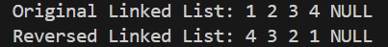
By :-> Nishant Bimra….

